Safety Committee Meeting Minutes Date: 6.4.25
Present: Tony Nubile, Denitsa Girard, Joe Krogman
Injury Update:
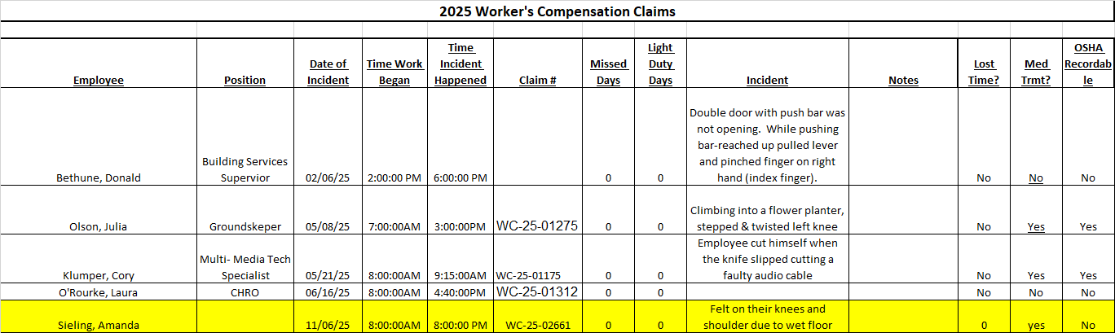

Drills: SS Fire drill, dorm evac drill
Inspections: Confined space evals
Dave’s report:
- Confined space evaluations complete on Academic Buildings
- AED’s: two new ordered to replace unsupported/obsolete machines, reshuffled locations, budget now in place for two replacement AED’s/ fiscal year
- IR camera from the state – going to safety directors
- ELM access
- Early retirement

Round Robin:
Joe K.: GMW’s are clearing snow as they do their unlocks; FA Blackbox theater – issue with seating, rolling chairs and unsecured elevated seating
Denitsa G.: Brought cookies, nothing to report
Tony N.: Snow removal is going well, causing overtime for our grounds crew; crews had to be called back for a flash freeze a few weeks ago; Insurance claims from July flood are in the final billing stage

