Safety Committee Meeting Minutes Date 7/22/2024
Present: Dave Hemp, Joe Krogman, Pat Daniels, Brad Besse, Pam Martinson, Tim Schrunk
Injury Update: One new - Highlighted
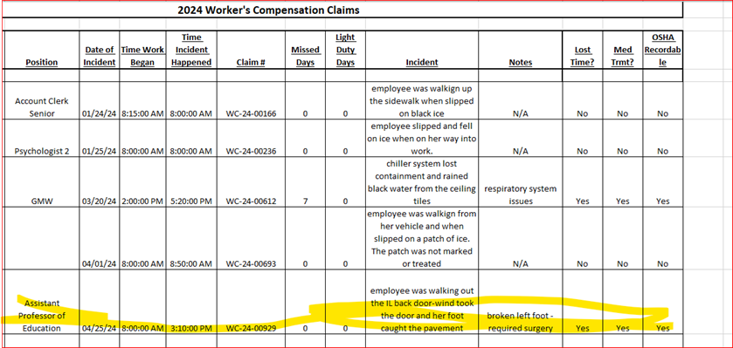
Drills: None to report
Inspections: Upcoming system visit – haven’t heard back exactly when they are coming; Pat - all Life Safety alarms have been inspected; Tim - Ansul fire suppression system was inspected, Fire Extinguisher inspections are August 5-9.
Dave’s report:
- Upcoming Hazardous Waste pickup
- Open fire extinguisher training 8/21 at 10am in BA 101
- New Cameras – only added to academic buildings, discussion was had regarding cameras in the hallways of the residence halls as there was significant damage to Sweetland hall exit signs this past spring
- AED Training: Please review: https://www.zoll.com/contact/elearning/videos/aed-plus#lightbox-81ca67a7-a122-40d3-bed3-e5ea93040426
Round Robin:
Joe: Nothing to report
Pam: Nothing to report
Brad: Nothing to report
Tim: Dryer vents have been inspected and cleaned
Pat: Concern with the ladder procedure currently used to change light bulbs in BA 101. Currently a “Little Giant” ladder system is being used with 4 GMW’s holding the ladder for one to climb. This practice seems to be unsafe.
Response: Mr. Hemp researched and found a mobile flexible scaffold system that can be used to safely changed: https://lightbulbscaffold.com/. Recommendation was made to Tony Nublie to use this.
Other: Fire alarm response in the SS building was discussed: according to Pat, SMSU will still monitor the alarm and will provide a response. The fire panel room will be accessible to SMSU employees but the building will have a secure area as well. Questions surround the SMSU Public Safety response. Public Safety will need to have access to check for actual fire, smoke or damage.

