Safety Committee Meeting Minutes Date: 6.4.25
Present: David Hemp, Tony Nubile, Pam Martinson, Joe Krogman, Brad Besse
Injury Update:
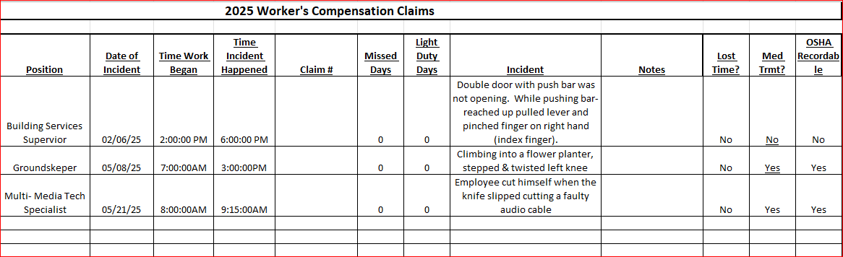

Drills: Evacuation drill cancelled – scheduling.
Inspections: Fire alarm systems were inspected two weeks ago, everything was good!
Dave’s report: - Attended Minnesota Safety Conference early May
- MN Safety Director’s mtg Jun 10-11, St. Cloud.
- Mercury Reduction from City of Marshall. Last in 2015; mercury thermometers
- Updating OSHA Programs
- Fire pit usage – do we need a procedure after scheduling?
- Weather watch notification feedback
- Veolia contacted for Haz Waste pickup
- Museum pickup
- Reminder: Outside work near traffic – safety vests required
Round Robin:
Joe: Nothing to report
Brad: Nothing to report
Pam: AED Training Video
Tony: RFP for AC repair in Bellows is in process – asbestos abatement will be an issue
Conference Center Elevator is in need of being rebuilt, in progress

