Safety Committee Meeting Minutes Date: 3.12.2025
Present: Dave Hemp, Brad Besse
Injury Update:
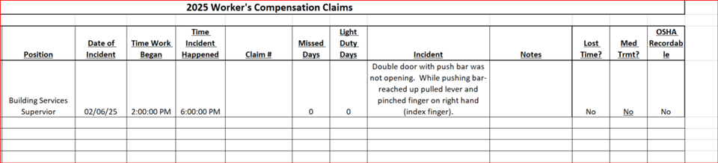
Drills: None to report
Inspections: Science Lab inspections:
Completed by Mr. Hemp over semester break.
- One fume hood in ST 256 taken out of service – did not pass airflow test.
Action: Notified maintenance and Dept. Chair. Looking at options
- Eyewash/safety showers not being tested monthly.
Action: Notified Lab Assistant to please test these monthly.
COPE Inspection: Insurance underwriter inspection, I was unable to attend. I provided information regarding security issues, Fire response and emergency response plans.

Dave’s report: Light bulb recycling – 833 bulbs recycled, $736.62
NARCAN placed in two AED boxes – RA and SC
Round Robin: Brad: Nothing to report

