SMSU Center for International Education (CIE)
Global Express
Vol 02 Issue 09 | January 20, 2021
- Welcome Back!
- Recap of MISO- Ice Skating
- FREE Blankets/Masks/Scarves & Gloves
- ISO Opportunities
- Mustangs Meetup - Coffee & Careers
- Apply for OPT
- Free Groceries
- HEALTH: Free COVID Testing

Welcome Back!
Hope you all had a great first week. The CIE wishes you a Happy New Year ahead and best wishes for this Spring Semester!

Recap of MISO - Ice Skating
At the Mandatory International Student Orientation (MISO), we welcomed 26 new international students from 7 different countries this Spring 2021 semester from Ethiopia, Brazil, Nigeria, Bangladesh, Germany, and Argentina. And, we are happy to welcome back two students returning from abroad.
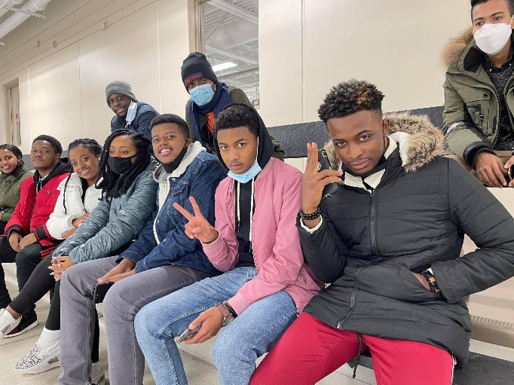
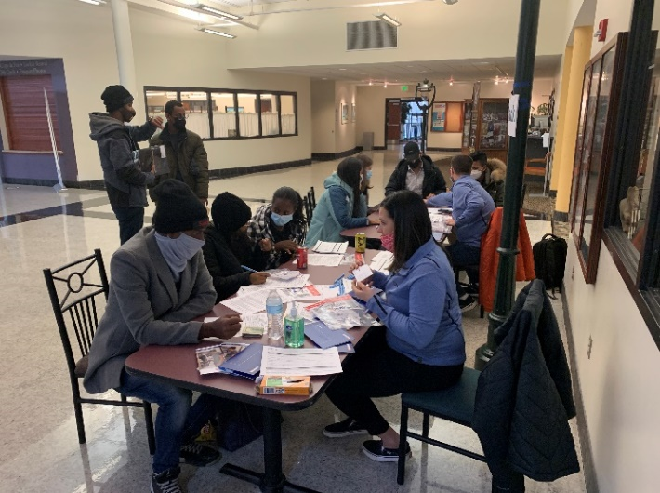
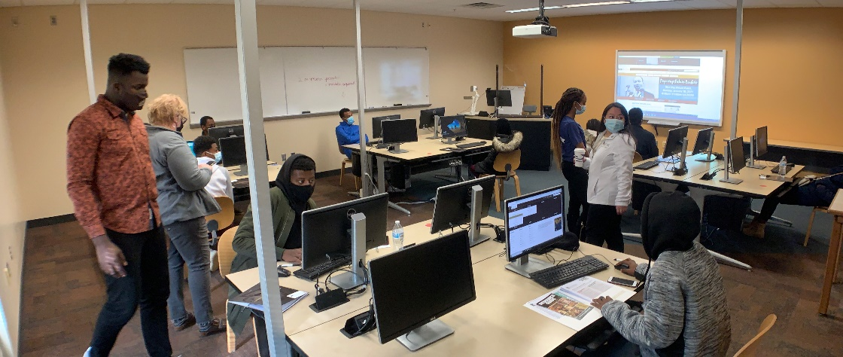

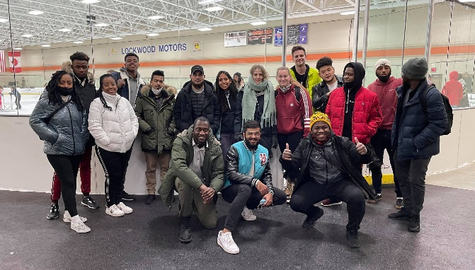
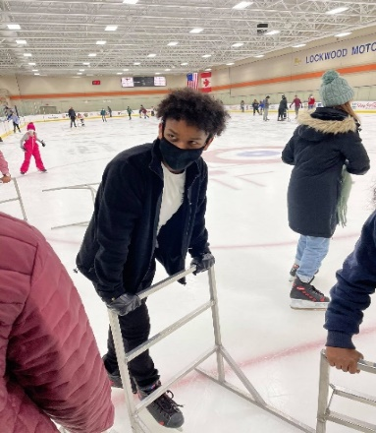

FREE Blankets, Mask, Winter Scarves & Gloves
Stop by the CIE office and pick up beautiful homemade blankets, gloves/scarves, and homemade holiday face masks (sewn by our very own Marilee Thompson in the Deans Office). First come first serve.
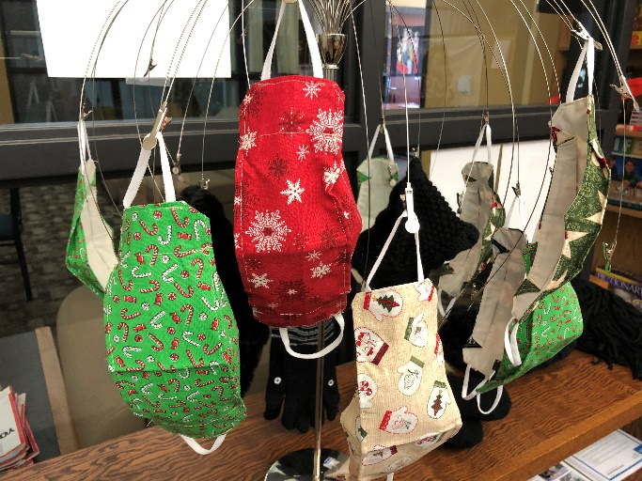
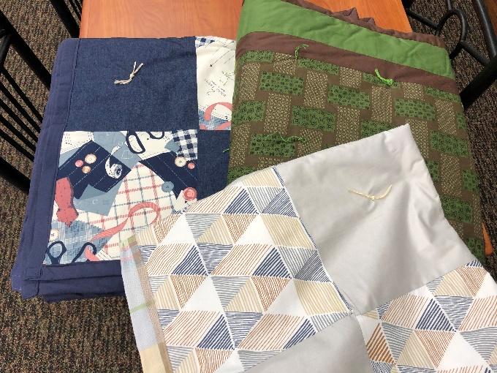

ISO Opportunities
International Student Organization (ISO) is also looking for new members this semester for new ideas and opportunities for club activities in this time of COVID. We want your feedback! Don’t hesitate to send us your thoughts and ideas. Join ISO Club
Mustangs Meetup: Coffee & Careers
Mustangs Meetup: Coffee & Careers will be held Tuesday, February 9, 2021. This is a career fair held virtually on Handshake from 11:00 a.m. - 2:00 p.m. Employers will be highlighting their organization's current/future opportunities for internships or full-time positions. This career fair will offer virtual 1-on-1 and group sessions. All majors are welcome to attend! For a growing list of attending employers, visit https://www.smsu.edu/campuslife/careerservices/students-alumni/on-campus-events.html or Log in to Handshake to learn more about the employers and register for 1:1 or group sessions.

Are you Graduating this May? Apply for OPT Now
Optional Practical Training (OPT) allows you to work anywhere in the U.S. in a job related to your major field of study after you graduate. This workshop is mandatory before you can apply. The application approval process takes 3-5 months. OPT fee is $550.
Zoom OPT Workshop - FRI | Feb 12 | 3:00 – 4:30pm
Register to Receive the Zoom information:
https://minnstate.zoom.us/meeting/register/tJcpd-iurD8jGtKOpfG4oC4VKoDuO1QJJf89

Free Groceries
Wednesday, January 20th- schedule pick up time at Bellows Academic 161, Center for Civic and Community Engagement. bit.ly/MustangMarketAppointment. For information, please contact civic.engagment@smsu.edu
H E A L T H
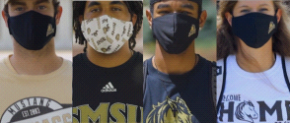
SMSU Mask Policy & COVID Self-Assessment
Southwest Minnesota State students are required to wear masks on campus. This is for everyone's safety as COVID is alarmingly contagious. Don't forget to fill out the COVID-19 Self-Assessment forms daily: https://mnscu.co1.qualtrics.com/jfe/form/SV_0oA2XakMFIL284Z
FREE COVID Testing
- Free testing available through the Hy-Vee Pharmacy by completing a pre-registration at doineedacovid19test.com.
- Download the free COVIDaware MN app to get notified if you have been near someone who tests positive for COVID-19.

Next issue: Volume 2 Issue 10 will arrive February 2nd we wish you all the best in your academic endeavors.
A publication of the SMSU Center for International Education
Student Center, Room 237
1501 State Street, Marshall, MN 56258

CENTER FOR INTERNATIONAL EDUCATION
OFFICE HOURS
Mondays - Fridays, 8:30am - 4:30pm
Walk-In Advising available Mondays - Thursdays, 12:00pm-4:00pm.
Visit, Call, or Email us during our Office Hours.
Phone: (507) 537-6018
Email: CIE@smsu.edu

