SMSU Center for International Education (CIE)
Global Express
Vol 02 Issue 17 | May 13, 2021

- Congratulations to all our Mustang Graduates!
- Are You Travelling Out of the US? Get your I-20 Signed!

Congratulations to all our Mustang Graduates!
Good luck to all of you on your next adventures!
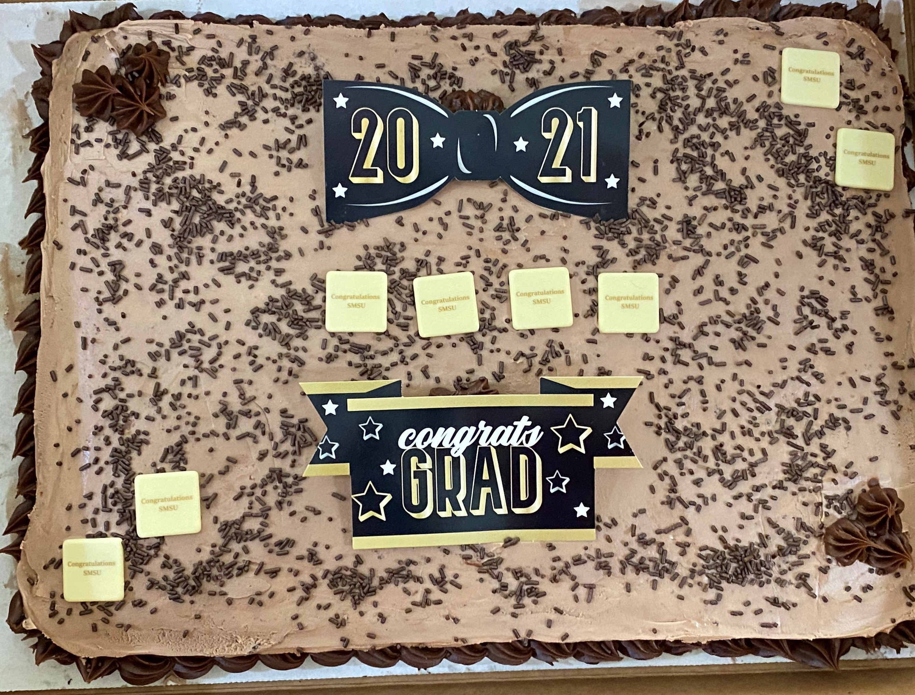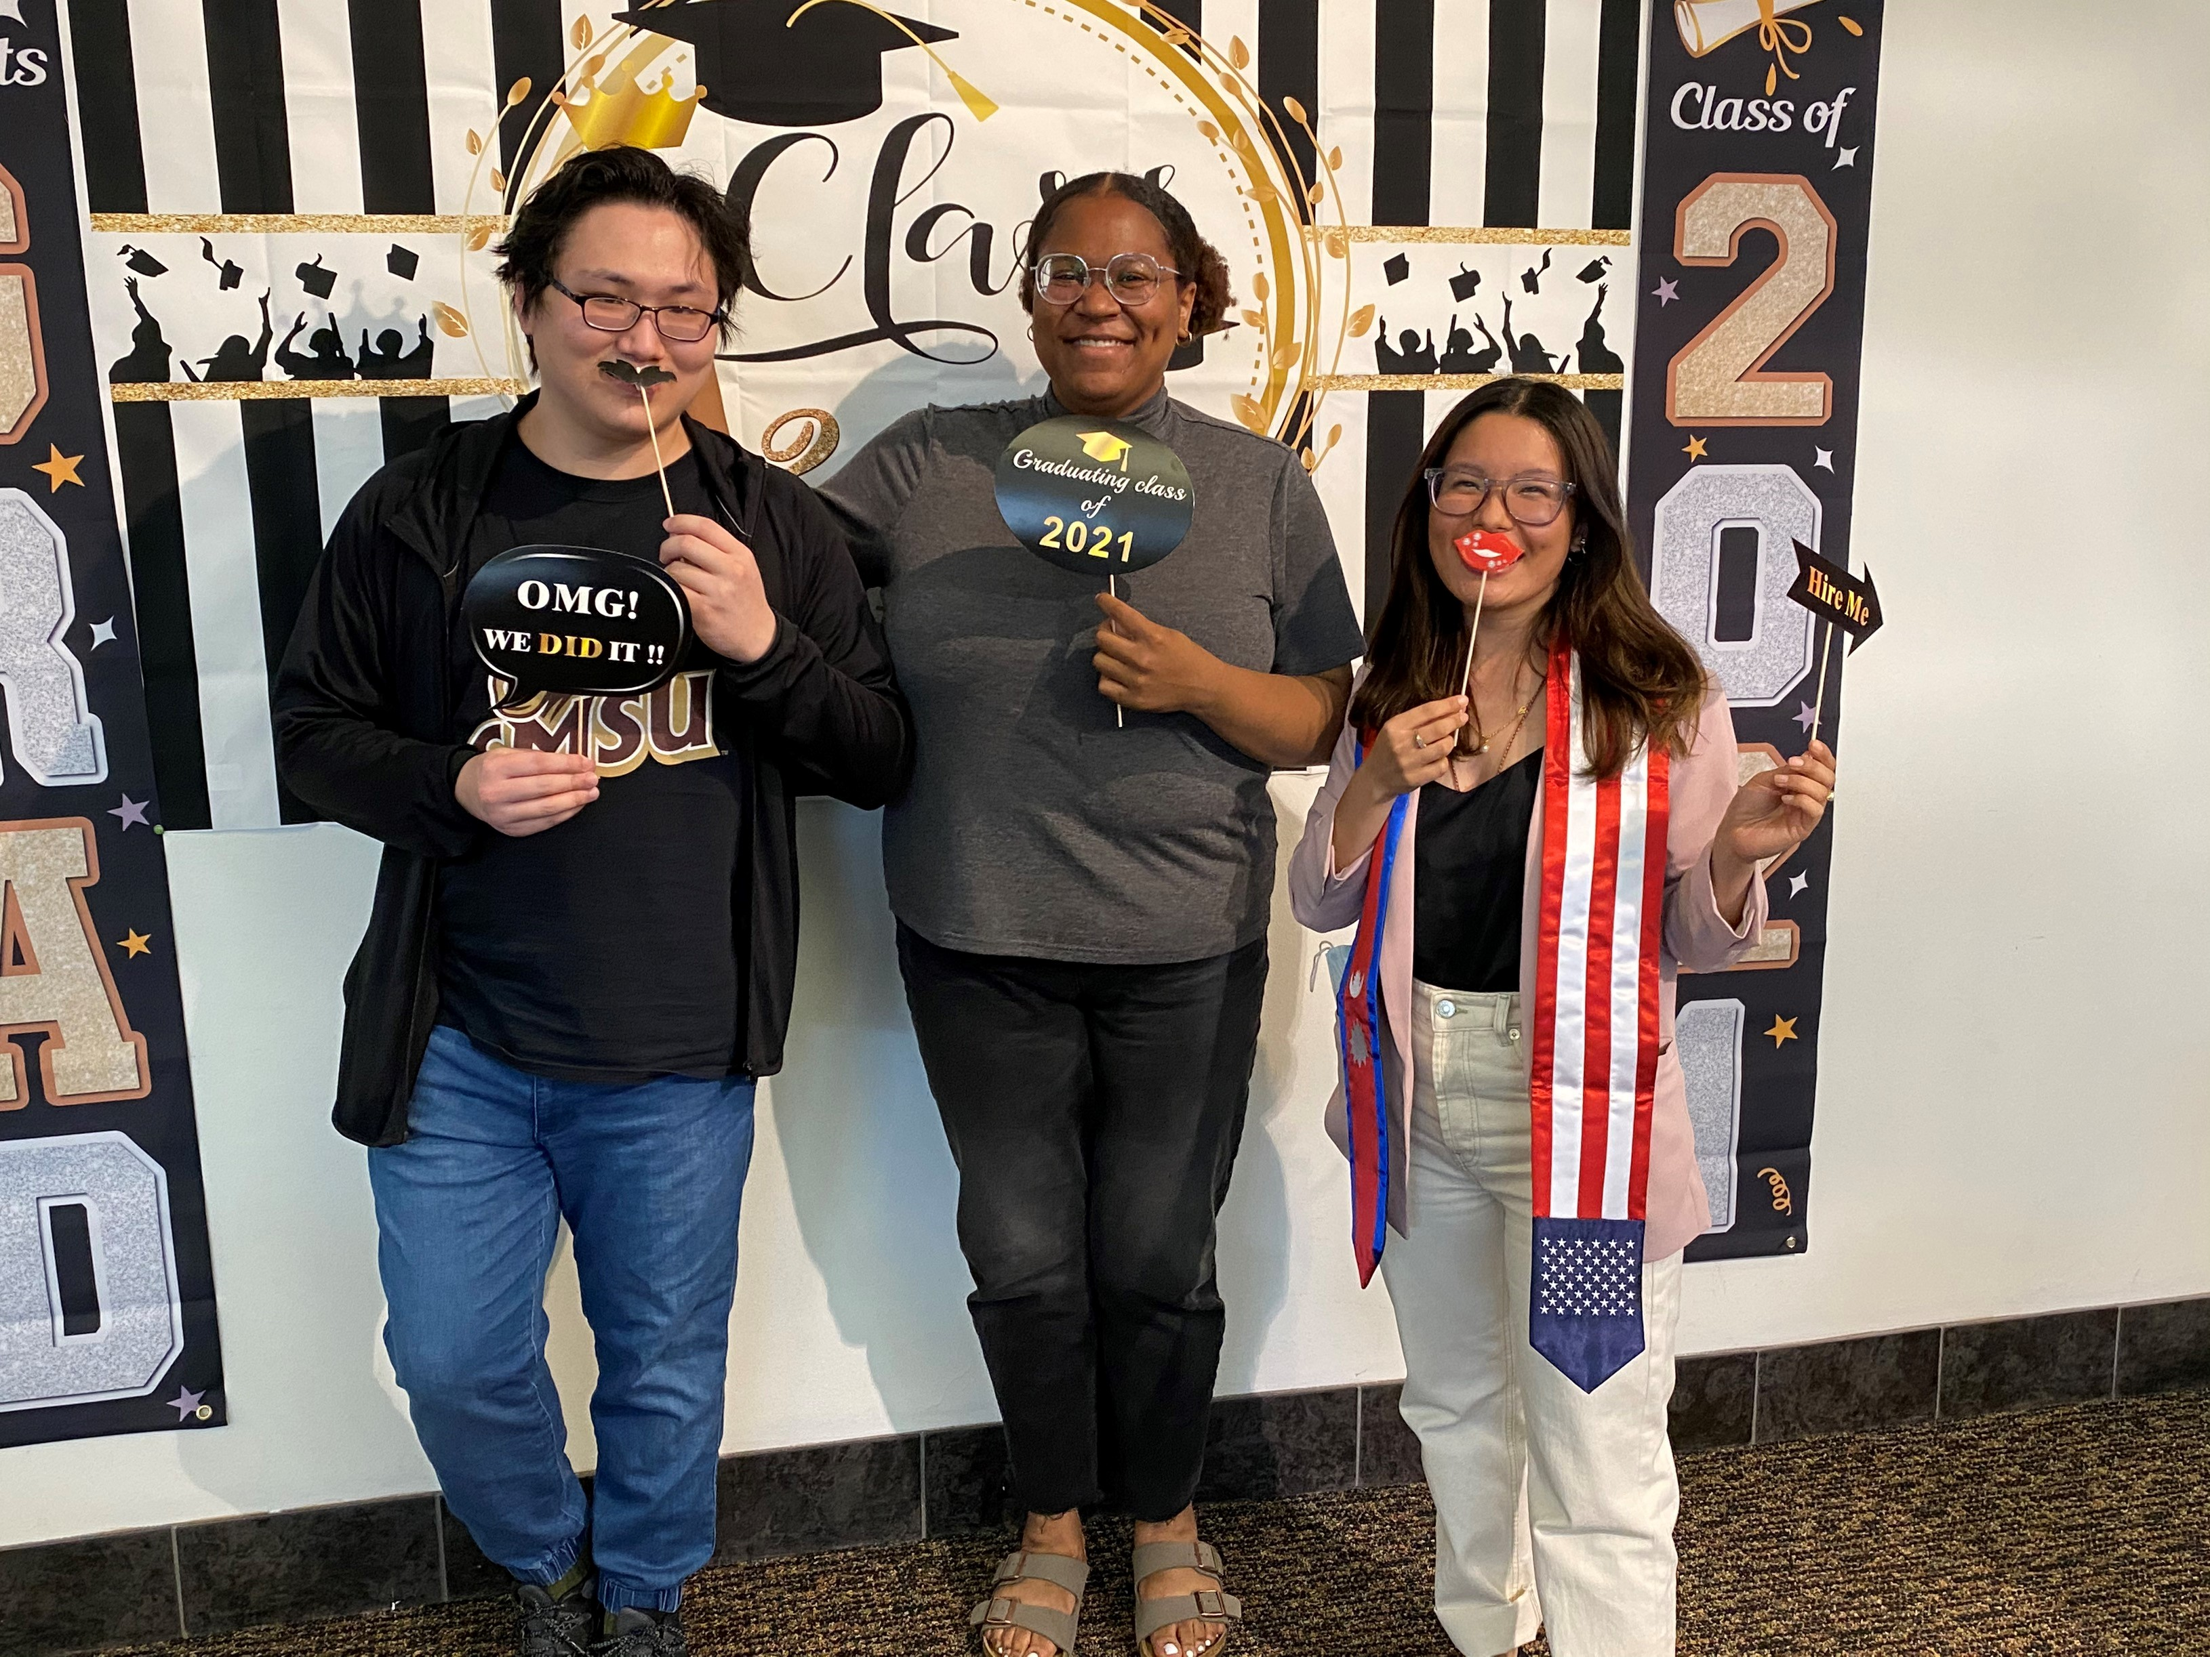
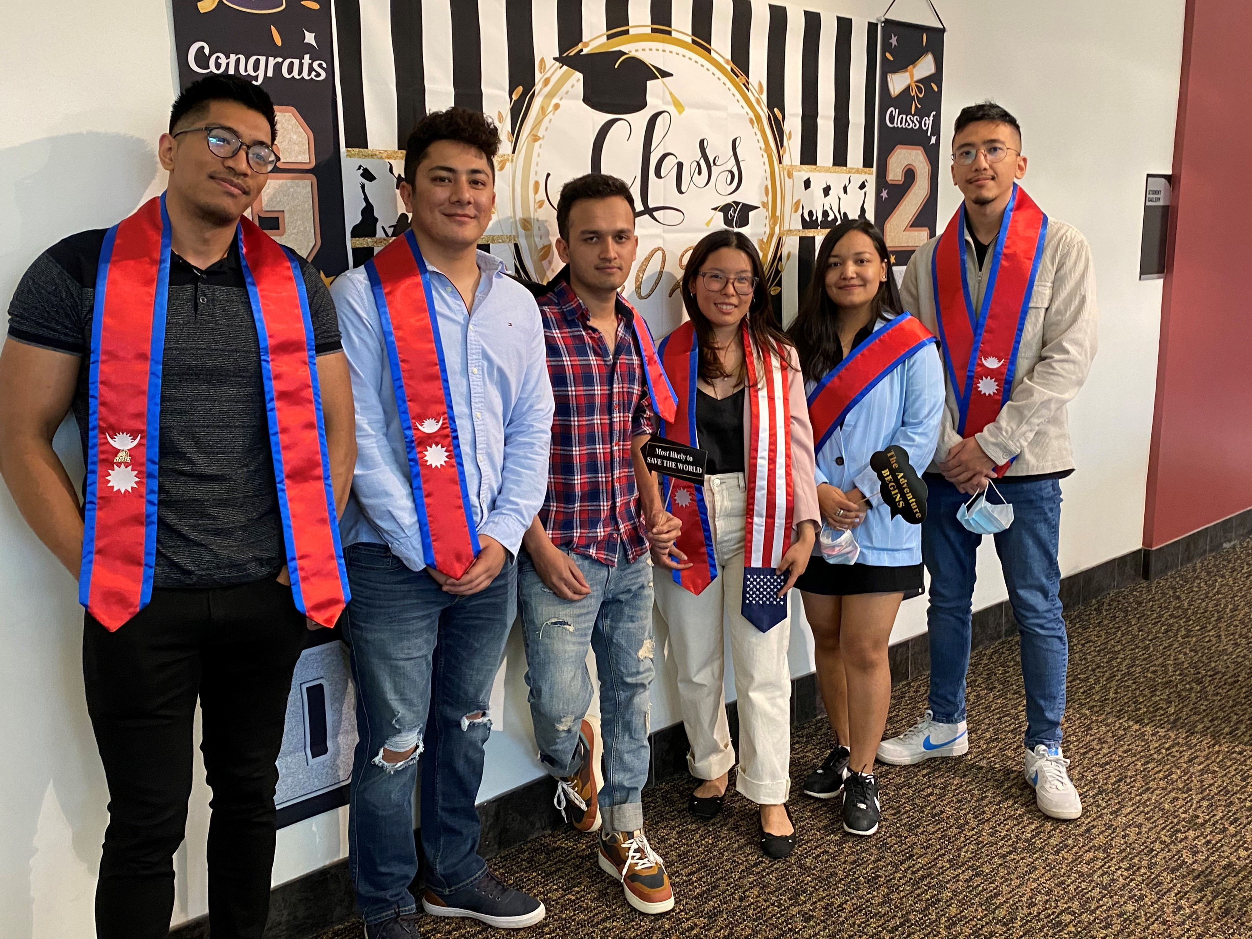
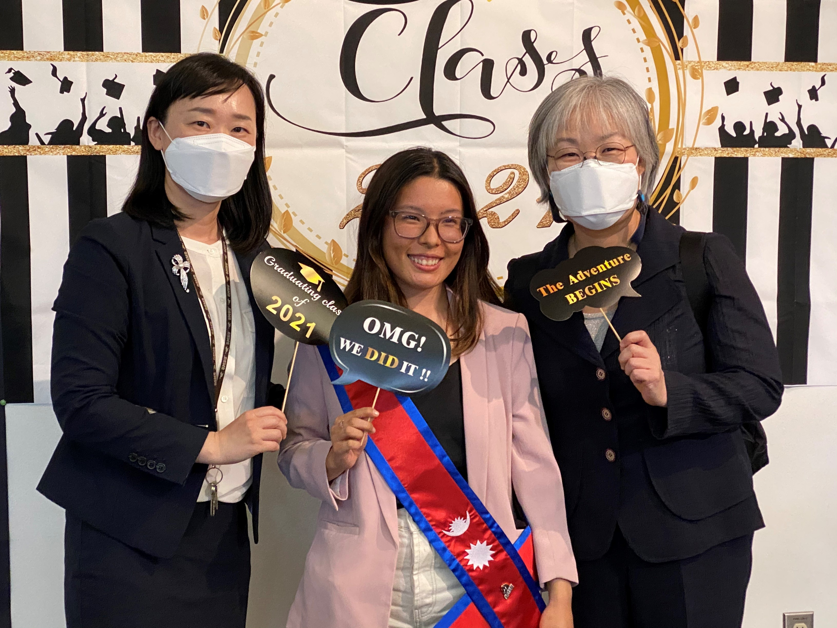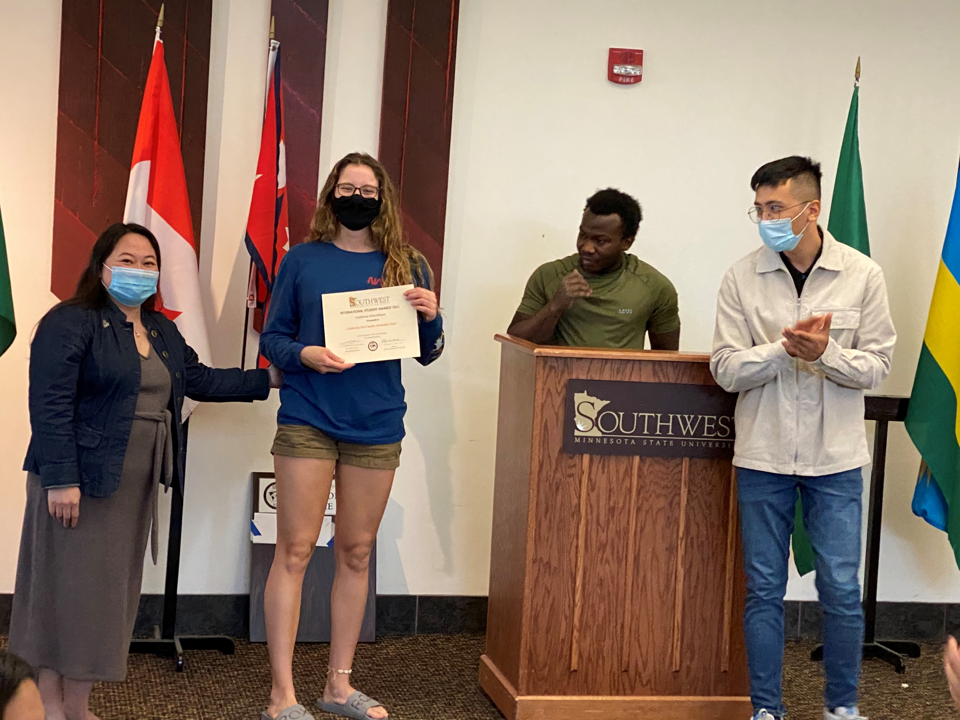

Are You Travelling Out of the US?
If you plan to travel outside of the US during summer break, please remember to stop by the CIE first. We do not recommend you travelling out of the US due to the pandemic, travel restrictions, and visa delays.
- If you must travel, please remember to get an official Travel Endorsement from the CIE on your I-20. Keep in mind this could take up to 2 business days so plan in advance and stop by early to get your I-20 signed for travelling.
- Check with CDC and US Department of State guidelines. CDC requires that you have a negative COVID test 3 days or less before departure.
- Check your Passport expiry date. It must be valid at least 6 months or more upon your entry to the US or you will be denied entrance.
- You must also have a valid F-1 visa at entry, if yours is expiring, make sure you apply for a new one in time before your return trip back. Keep in mind many US Embassies are closed for visa applications and those open are experiencing a long waiting period for appointments.

Next issue: See you in the Aug for our next issue!
A publication of the SMSU Center for International Education
Student Center, Room 237
1501 State Street, Marshall, MN 56258

CENTER FOR INTERNATIONAL EDUCATION
OFFICE HOURS
Mondays - Fridays, 8:30am - 4:30pm
Walk-In Advising available Mondays - Thursdays, 12:00pm-4:00pm.
Visit, Call, or Email us during our Office Hours.
Phone: (507) 537-6018
Email: CIE@smsu.edu

