SMSU Center for International Education (CIE)
Global Express
Vol 02 Issue 11 | February 17, 2021
- Don’t Forget to File Your Taxes – Yes, even if you didn’t work
- International Coffee Hours
- YES, You Can Study Abroad!
- Students United Scholarship

Don’t Forget to File your Taxes
International students must file U.S. taxes every year even if you did not work.
- If you did not work last year, you simply need to fill out the Form-8843 available in the CIE office.
- If you worked some or all of last year, you will need to collect your W-2 tax forms to file
taxes with the U.S. IRS (Internal Revenue Service). If you worked on-campus, access and print out your W-2 form by logging onto E-Services. Under My Dashboard you will see a link to your W-2.
The CIE staff are not licensed to assist with tax filing. There are several online tax services available to choose from. Sprintax, is a tax service that specializes in U.S. Tax Preparations for Nonresidents. You may file your taxes online through Sprintax https://www.sprintax.com/ .

International Coffee Hours
Come to the CIE for International Coffee Hours these following Fridays at 3:00PM-4:30PM. Enjoy coffee, drinks, and some fun. Come early while supplies last!

- Feb 26: Relax and Color with Us
- March 5: Celebrate International Women’s Day – Make a Goody Bag for a Woman in Your Life
- March 19: Origami Fun
- April 2: Decorate an Easter Egg & Enjoy Some Easter Candies
- April 16: Try Your Hand at Arts & Poetry
- April 30: Celebrate Our Graduates!

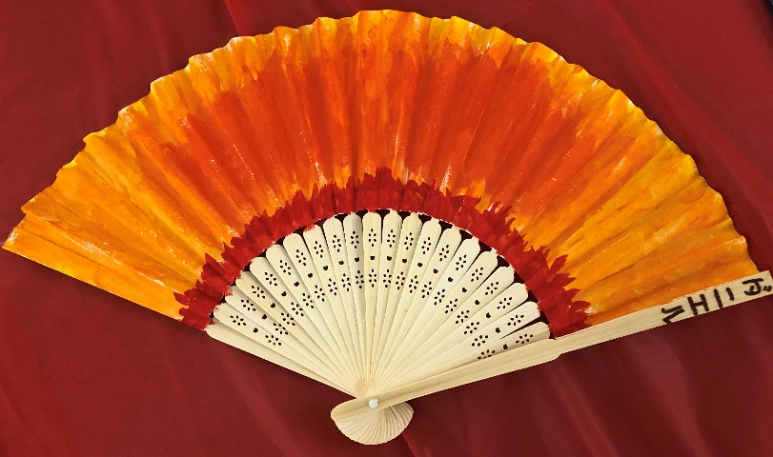
Here’s a peak at from last week’s International Coffee Hours celebrating Asian Lunar New Year and Valentine’s Day. 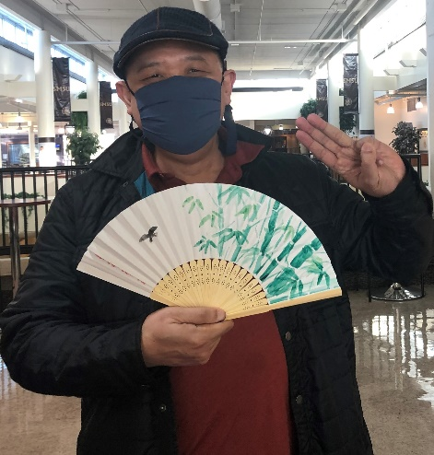

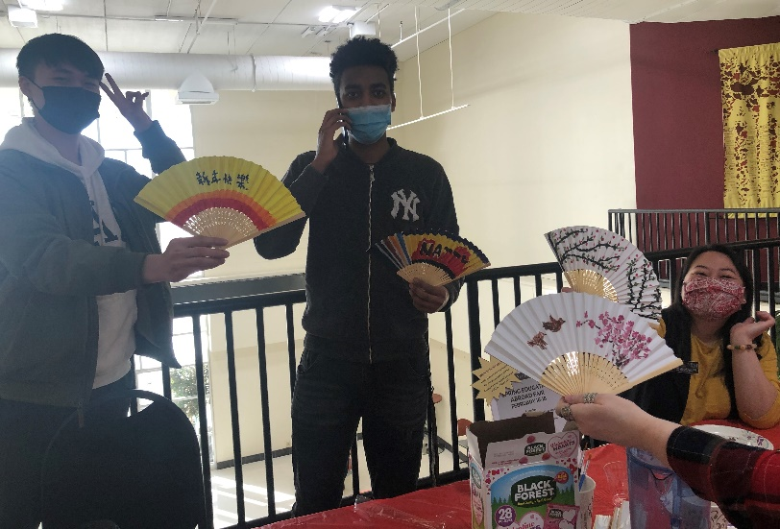
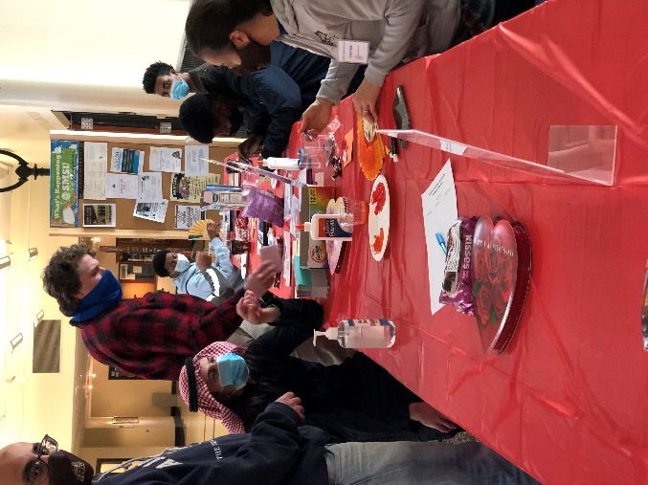

YES, You Can Study Abroad!
Learn how you can study abroad at these information sessions.
Stop by the CIE if you have any questions and schedule your appointment for study abroad advising today.
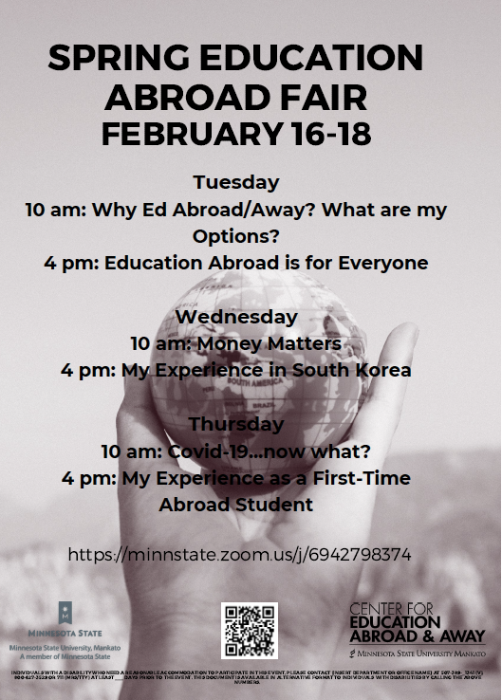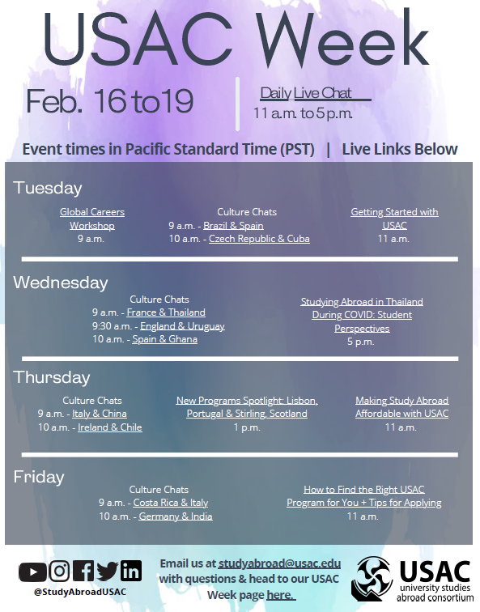
Students United Scholarship
We have seven scholarship that are available for next year. Scholarship awards range from $500-$5,000 and are open to international and undocumented students as well. Applications are now open and are due on April 1st. Please check out full details here: https://www.studentsunited.org/scholarships

If you have specific questions, please reach out to our Development Intern, Mio Yoshizaki, at development@studentsunited.org or Director of Development, Christina DeVries, at cdevries@studentsunited.org

Next issue: Volume 2 Issue 12 will arrive March 2.
A publication of the SMSU Center for International Education
Student Center, Room 237
1501 State Street, Marshall, MN 56258

CENTER FOR INTERNATIONAL EDUCATION
OFFICE HOURS
Mondays - Fridays, 8:30am - 4:30pm
Walk-In Advising available Mondays - Thursdays, 12:00pm-4:00pm.
Visit, Call, or Email us during our Office Hours.
Phone: (507) 537-6018
Email: CIE@smsu.edu



