SMSU Center for International Education (CIE)
Global Express
Vol 02 Issue 10 | February 1, 2021
- Passport Renewal & Address Updates
- File Your Taxes – Yes, even if you didn’t work!
- Mustang Meetup Career Fair
- OPT Workshop
- International Coffee Hours
- Math & CS Scholarship
- Campus Events

Passport Renewal

International students must always have a valid international passport during your stay in the U.S. If your passport is about to expire and/or has expired please renew your passport right away.

Address Updates
International students must always have a valid international home address located in the Permanent and International address fields in your student e-Services account. You must also list a valid local address where you are residing while studying at SMSU. The US federal regulations require that you update your addresses each time you move within 10 days. Please check and make sure your addresses are accurate in e-Services.

File your Taxes
International students must file U.S. taxes every year even if you did not work.
- If you did not work last year, you simply need to fill out the Form-8843 available in the CIE office.
- If you worked some or all of last year, you will need to collect your W-2 tax forms to file
taxes with the U.S. IRS (Internal Revenue Service). If you worked on-campus, access and print out your W-2 form by logging onto E-Services. Under My Dashboard you will see a link to your W-2.
The CIE staff are not licensed to assist with tax filing. There are several online tax services available to choose from. Sprintax, is a tax service that specializes in U.S. Tax Preparations for Nonresidents. You may file your taxes online through Sprintax https://www.sprintax.com/ .

Mustangs Meetup Career Fair
Mustangs Meetup: Coffee & Careers will be held Tuesday, February 9, 2021.
This is a career fair held virtually on Handshake from 11:00AM - 2:00PM.
All majors are welcome to attend! Log in to Handshake to learn more about the employers and register for 1:1 or group sessions. For a list of attending employers, visit https://www.smsu.edu/campuslife/careerservices/students-alumni/on-campus-events.html .

OPT Workshop
Optional Practical Training (OPT) allows you to work anywhere in the U.S. in a job related to your major field of study after you graduate. This workshop is mandatory before you can apply. The application approval process takes 3-5 months. OPT fee is $410.
Zoom OPT Workshop - THUR | Feb 11 | 3:00PM – 4:30PM
Register to Receive the Zoom information:
https://minnstate.zoom.us/meeting/register/tJcpd-iurD8jGtKOpfG4oC4VKoDuO1QJJf89

International Coffee Hours
Come to the CIE for International Coffee Hours these following Fridays at 3:00PM-4:30PM. Enjoy coffee, drinks, and some fun. Come early while supplies last!

- Feb 12: Celebrate Asian Lunar New Year & Valentine’s Day – Paint Fans & Make a Card
- Feb 26: Relax and Color with Us
- March 5: Celebrate International Women’s Day – Make a Goody Bag for a Woman in Your Life
- March 19: Origami Fun
- April 2: Decorate an Easter Egg & Enjoy Some Easter Candies
- April 16: Try Your Hand at Arts & Poetry
- April 30: Celebrate Our Graduates!

Math & Computer Science Scholarship
The Math & Computer Science Department has various scholarships available for Math, Math ED, and Computer Science Majors. Click here to Apply online at https://smsu.academicworks.com.

Fun Campus Events This Week!
- Tuesday: Virtual Painting Social- Supplies can be picked up between 1:30PM-3:30PM in the Upper Student Center. Virtual instructions are at 8:00PM
- Wednesday: Comedy Unmasked- 8:00PM Via Zoom, Meeting ID: 586 649 8823
- Thursday: Blacklight Mini Golf- 2:00PM-5:00PM in the Lower conference center. Sign up for a time with Aaron.Bible@my.smsu.edu and make sure to wear your white/glow in the dark clothing.


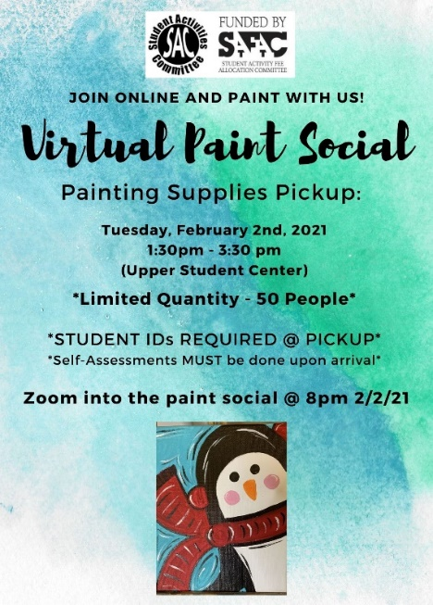


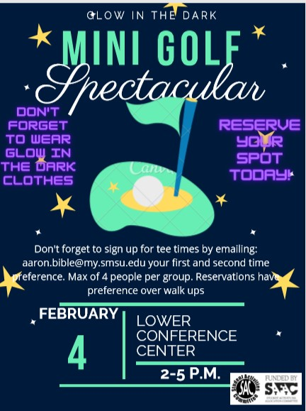

Next issue: Volume 2 Issue 11 will arrive February 16.
A publication of the SMSU Center for International Education
Student Center, Room 237
1501 State Street, Marshall, MN 56258

CENTER FOR INTERNATIONAL EDUCATION
OFFICE HOURS
Mondays - Fridays, 8:30am - 4:30pm
Walk-In Advising available Mondays - Thursdays, 12:00pm-4:00pm.
Visit, Call, or Email us during our Office Hours.
Phone: (507) 537-6018
Email: CIE@smsu.edu



