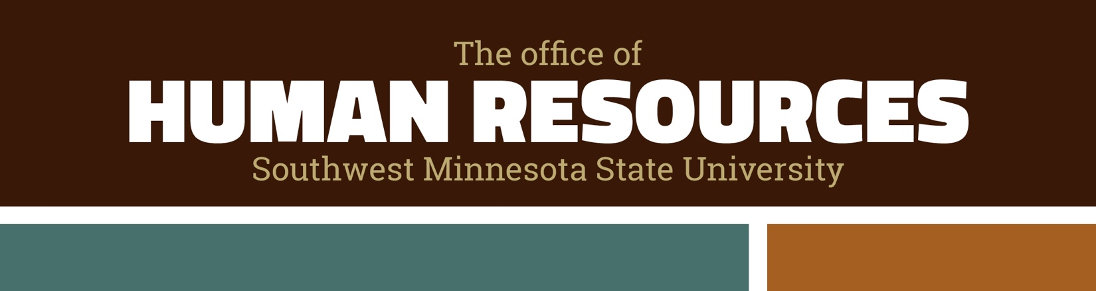
Search Advisory Confidentiality Agreement

I understand that as an employee of Minnesota State and/or a member of a search advisory/screening committee, I will receive information on applicants and employees that is classified as private data under the Minnesota Government Data Practices Act, Minnesota Statutes Chapter 13. I understand that violating data privacy can be both a university liability as well as a personal liability. I hereby agree to keep such information private and not disclose the names of applicants or any other information about an applicant or employee, unless authorized to do so. This includes information discussed by the search committee members regarding applicants and employees. Information must be kept confidential even after the search is completed and the identity of all applicants is private until the candidates are finalist.
I acknowledge that failure to comply with this agreement could subject me to discipline and/or the institution to legal claims under applicable privacy laws.
Title of Position Being Searched

Printed Name
Signature | Date

