University Supervisor Guide
SMSU Clinical Experience Placements
Student Learning and Licensure (SLL)

Sign in directions:
It is recommended to perform the below steps in a private window (or incognito window) in any browser of your choice.
- To launch a private window (or incognito window) on a windows, Linux, or Chrome OS, open a browser of your choice and then press Ctrl+Shift+n. Mac: Press ⌘ + Shift + n
- Copy and paste this link to your private window URL https://login.watermarkinsights.com/connect/smsu
- Enter your login username: which is your starid@minnstate.edu and click on “Next”
- Enter your starid password and click on “Sign in” and then go through your multi-factor authentication process to complete your sign in.

Note: If this is your first time logging into with your Office 365 account, it will prompt you to set up your Multi-Factor Authentication

Notice the top bar when you log in. If you supervise for another institution that also uses SLL, you will want to make sure you are at Southwest Minnesota State University. You may also use the question mark to find help navigating the system. The bell will have notifications for you if a student has submitted something since the last time you logged in.

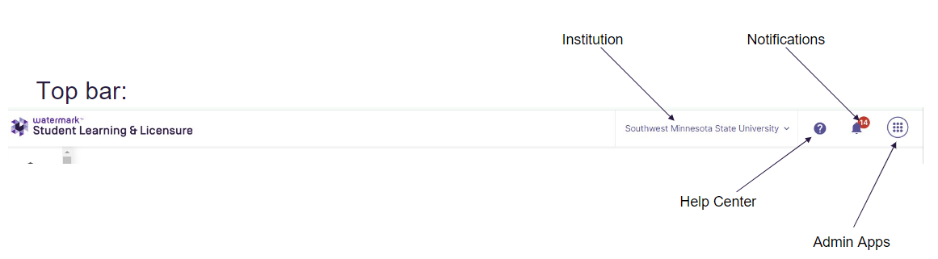

Upon logging in you should land on your “In Progress” page. You will notice on the left side of your screen the “In Progress” tab is highlighted. On this screen you will notice you can search by course number and semester. This is especially important if the semester ends, and you need to go back to view an assignment.
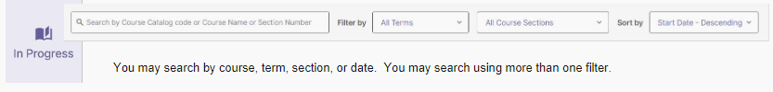
Once you locate the course and section that you need you can click on the purple name for the course or the View Details button. Either will take you to the same screen for the course details.
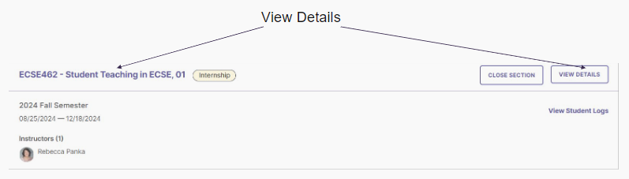
SCORING ACTIVITIES:
Across the top of the screen, you will see Activities, Homepage, Members, Scores, and Student Logs for the course. To view and score an activity you will want to be on the Activities tab. It will appear darker and underlined.
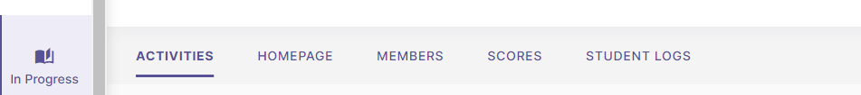
Click on the activity you want to assess by clicking on its name or the View Details button.
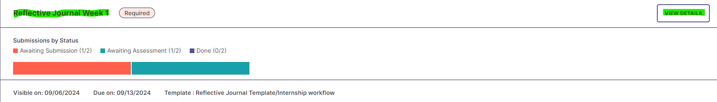

On the next screen you should see only the candidates you are assigned to. If you see more than the candidates assigned to you, let the Office of Placement and Licensure know. (Stephanie Fladhammer or Rebecca Panka)
If the activity requires the candidate to turn something in, you will see if they have turned in a document by the middle column. If there is a circle with 0/1 that means they have submitted and are waiting for you to view and score it. You can click on their name or anywhere in their row to view their submission.
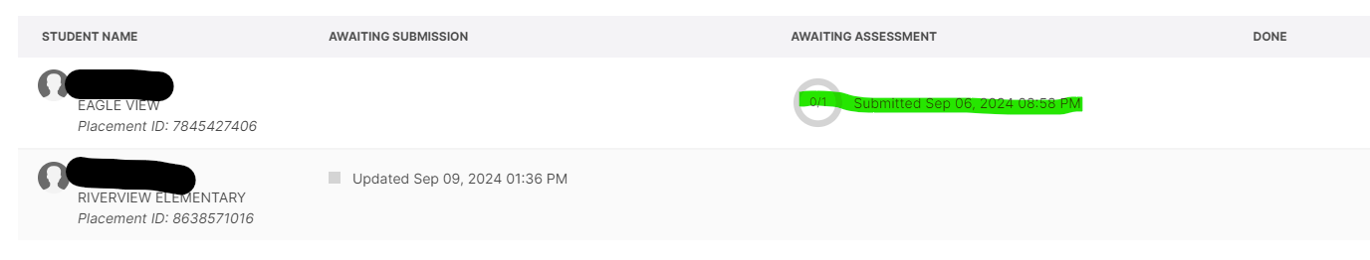
On the assessment screen you will see the student’s submitted document on the left side and a rubric on the right side. Click on “eye” icon to view the file or click on the “download” icon to download and then view it. If you use the “eye” icon you can leave comments right on the student submission. Click on the “view rubric details” to see a bigger version of the rubric.
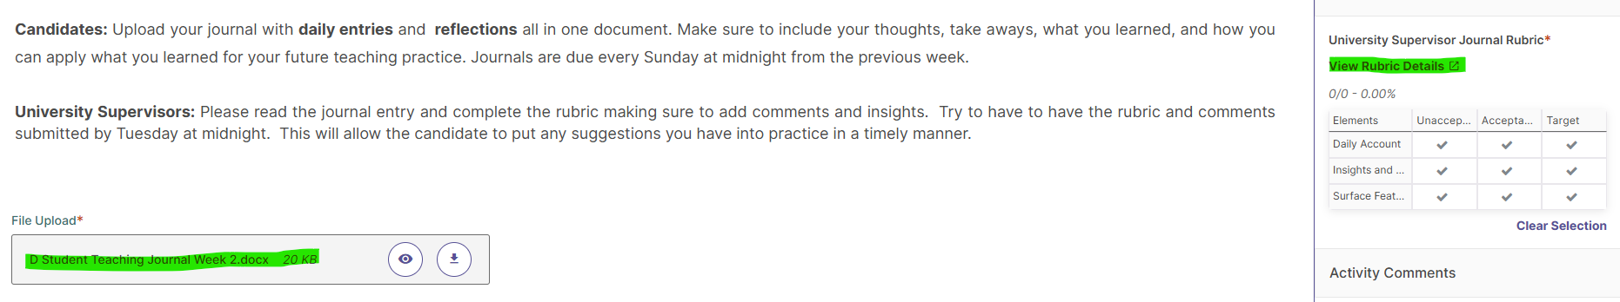

Download
Eye/View

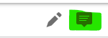
If you use the “eye” or view option you can click on the call out box to leave comments throughout the document for the student to view. Click on the callout box and a plus sign will replace your cursor. Click the plus sign on the document where you want to leave a comment.

You may request a resubmission if the candidate said they forgot to submit something or if you don’t think their submission is sufficient. You can also save your progress, cancel your progress, or submit when you are done filling out the rubric.

After you submit, the activity should show up in the “done” column on the previous page. I believe I will also show up in your timeline. If the activity also needs to be submitted by the CT, it will not show up in the done column until you both have submitted.

VIEWING COMPLETED ACTIVITIES:
Get into the activity for the student just as you would if you were going to score the activity. To view what you have submitted or what has been submitted by the CT, you need to access the “ASSESSMENTS HISTORY” tab.
Once in the history you will see the date you or the CT submitted. If you want to check to make sure your submission saved, you can click on your own name. If you want to see what the CT has submitted, you can click on their name. Note: You know they have submitted something if there is a date by their name. If there is no date, then they haven’t submitted yet.
After clicking on a name you will see any documents they submitted and/or the rubric they submitted. You will need to click on the document submission to be downloaded for viewing. You will need to click on the “view rubric details” to view the full rubric and comments. This is the only way to view the comments.

OBSERVATIONS:
Student teachers typically need 4 observations and practicum candidates need 2 observations.
You will find activities titled, “Lesson and University Supervisor Observation #”. You may click on the purple name for the activity or the “View Details” button.
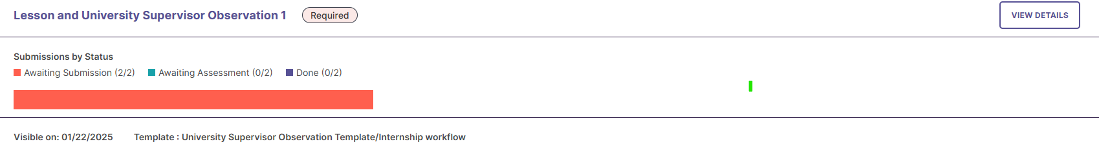
You may then click on the row with the candidate’s name to get into the activity. First the candidate must upload their lesson plan. You will not see a spot to upload your document until theirs is submitted. Please fill out the lesson plan rubric and leave comments either on the document using the directions in the previous section or on in the rubric. Click Save, if you don’t you will need to fill out the rubric again. Once you have completed the observation, then you can use the “university supervisor section” to upload your observation document. Click the “Select File” button.
Then, you will need to locate your file by clicking the “add file” purple button. The last step is to click the “insert” button once your file is uploaded. Make sure to hit SUBMIT when you are done with the rubric and you have uploaded your documentation.
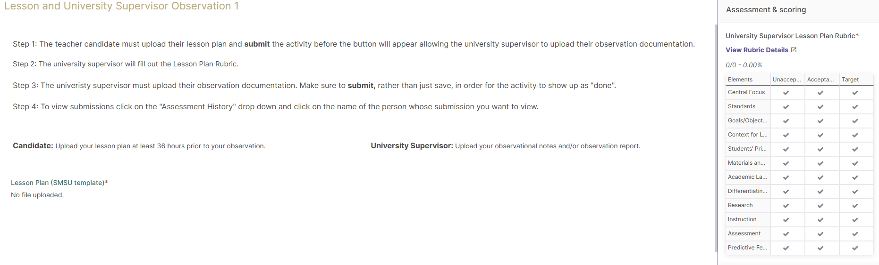

TRIADS:
You will find activities titled, “University Supervisor Triad #”. You may click on the purple name for the activity or the “View Details” button.
The process will be the same as it was for uploading your observation document. You may then click on the row with the candidate’s name to get into the activity. Once in the activity you should see a spot under “university supervisor” to upload your document. Click the “Select File” button.
Then you will need to locate your file by clicking the “add file” purple button. The last step is to click the “insert” button once your file is uploaded. Don’t forget to hit SUBMIT when you are done.

